|  |  |
| --- | --- |
| **Lab Questions-3** | |
|  |
| **Course Code: CSE 107** |
|  |

**Tips**: Also please try to solve the **Self Review Exercises** and **Exercises from the Text Book provided**

1. Write an object oriented program that uses a *for* statement to calculate and print the average of several integers. Assume the last value read is the sentinel 9999. A typical input sequence might be

10 8 11 7 9 9999

indicating that the program should calculate the average of all the values preceding 9999.

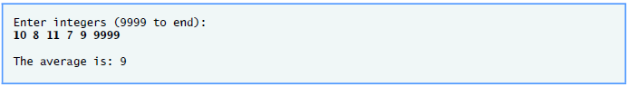

2. Write an object oriented program using **repetition statement** that prints the following diamond shape.

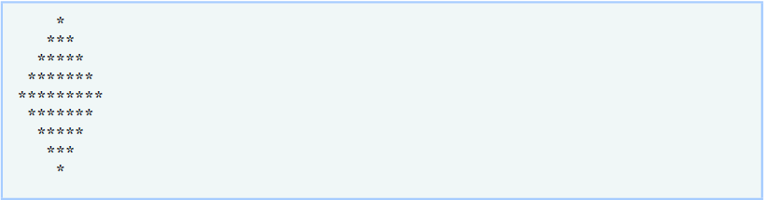

3. The factorial of a non-negative integer *n* is written *n*! (pronounced “*n* factorial”) and is definedas follows:

*n*! = *n* · (*n* – 1) · (*n* – 2) · … · 1 (for values of *n* greater than 1)

and

*n*! = 1 (for *n* = 0 or *n* = 1).

For example, 5! = 5 · 4 · 3 · 2 · 1, which is 120.

Write an object oriented program that estimates the value of the mathematical constant  by using the formula:



4. Write an object oriented program that reads in the size of the side of a square and then prints a hollow square of that size out of asterisks and blanks. Your program should work for squares of all side sizes between 1 and 20. For example, if your program reads a size of 5, it should print:

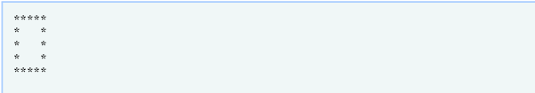

Sample Output:

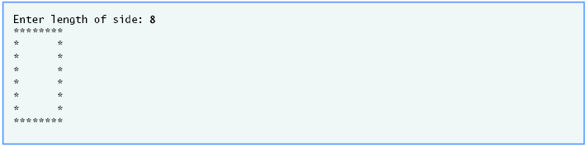

5. Develop an object oriented program that uses a while statement to determine the gross pay for each of several employees. The company pays “straight time” for the first 40 hours worked by each employee and pays “time-and-a-half” for all hours worked in excess of 40 hours. You are given a list of the employees of the company, the number of hours each employee worked last week and the hourly rate of each employee. Your program should input this information for each employee and should determine and display the employee’s gross pay.

Enter hours worked (-1 to end): **39**

Enter hourly rate of the employee ($00.00): **10.00**

Salary is $390.00

Enter hours worked (-1 to end): **40**

Enter hourly rate of the employee ($00.00): **10.00**

Salary is $400.00

Enter hours worked (-1 to end): **41**

Enter hourly rate of the employee ($00.00): **10.00**

Salary is $415.00

Enter hours worked (-1 to end): **-1**